MY WEIGHT app
User Guide/Instructions/Support Manual

Installation
- This app requires access to your Fitbit profile in order to retrieve the weight information. Therefore, upon installation, go to the settings menu and log on to your Fitbit account.

- A screen will pop up requesting after logging in, requesting that you grant access to your Fitbit account, like below. Fitbit will only allow access for one day at a time before needing to re-login; but there may be times when it will update by itself without needing to do it that often. Refer to the “Authorisation” section for more information. Meanwhile if you are OK with it, please tick the Allow All box then the Allow button to continue.

- Please note that your Fitbit information will only be available to you and no one else. BV Designs cannot and will not store or distribute your personal information in any way.

- Once the login is successful, you should see your weight information for the last seven days in the form of a line graph, with the readings below. The weight will display in either pounds, kg or stones depending on your Fitbit profile (kg default). It will also show your weight goal if you added it to the official Fitbit mobile app.

- You can also choose in the settings toggle whether you wish to see your BMI or body fat. If it shows up as undefined and you wish to see them, record in the Fitbit mobile app.

- You can then choose your favourite background colours and date format to complete the look.

Authorisation screen

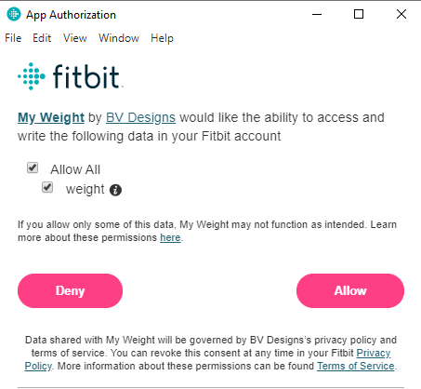

Logging a new weight

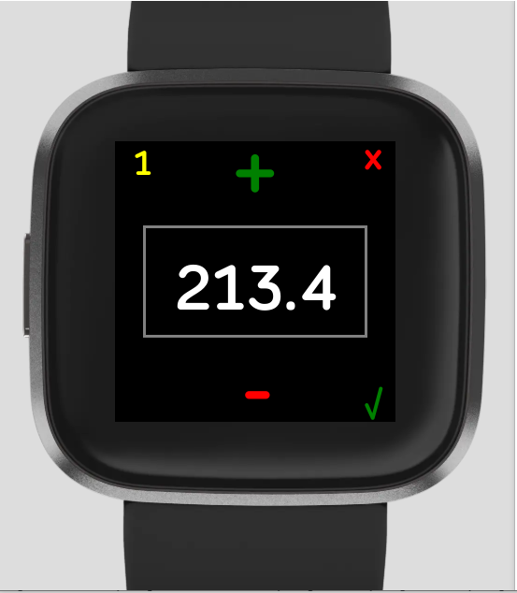

Please note the following: -
- You can add a new weight log directly on your Fitbit device and it will be recorded on your profile and in the mobile app, logged with the date and time of entry. You will not be able to add a log for a previous or future day.
- You can add as many changes as possible and although they will successfully record on your Fitbit profile and the mobile app, you will not see the change on your Fitbit device after the second entry. In order to see the change, you will need to go to the mobile app to remove the log you don’t want.
For example:-

Current record | 1 Jan 08:30 – 115 lbs | displayed on device
New log from device | 1 Jan 11:30 – 117 lbs | displayed on device
New log from device | 1 Jan 16:30 – 112 lbs | displayed on app but not device which will still display 117 lbs
REMOVE log from app | 1 Jan 11:30 – 117 lbs | 112 lbs will now display on device.

To log a new weight:
- Tap the current weight at the top to display the new log screen as seen above. The current weight will be shown as the starting point.
- You can enter the weight in 1 or 0.1 increments. The yellow 1 at the top indicates that the increment is currently 1; if you want to change this tap on the 1 so it changes to 0.1 and tap back if you want 1 again.

- Tap either the “+” or “-“ to increase or decrease the weight by the increment displayed.

- If you wish to cancel at this point, press the “x” to return to the main screen, otherwise when the weight is the required number, press “✔”. The new weight will display on the device in a short while.

- To see if that new log has been sent to the app, the quickest way to see the change is to force close the app and open it again. All changes should be followed by a force close and reopen.

Authorisation

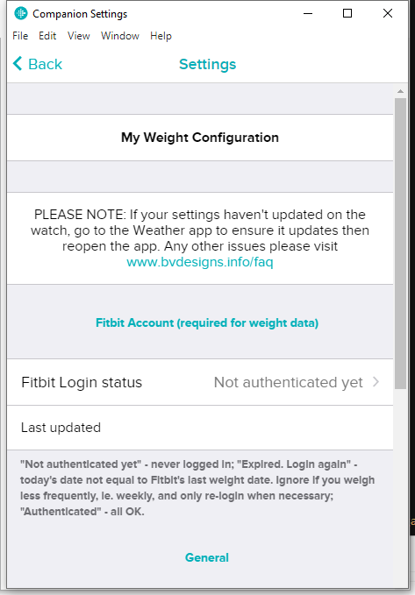

To view the latest weight updates on the device, in most cases all that is necessary is to reload the application. But there are times when it will be necessary to refresh the access, which requires re-authorisation by tapping the login option in the settings menu.

The status will indicate whether you need to re-login or not: -
- "Not authenticated yet": Never logged in as it’s the first installation. You will need to log in to see your weight information.
- "Expired. Login again": Today's date not equal to the date of the last weight stored. This is most helpful if you weigh every day. Ignore if you haven’t logged a weight yet for that day, or if you weigh less frequently, ie. weekly, and only re-login when necessary.
- "Authenticated" - all OK; everything updated.

Any other queries please go to https://www.bvdesigns.info/faq

